**Project Description: OLAP Operations (using PostgreSQL)**

**Objective:**

The objective of this project is to perform OLAP (Online Analytical Processing) operations on the "sales_sample" table to gain a deeper understanding of sales data through different dimensions, aggregations, and filters. This project includes the following tasks:

**Step 1: Database Creation**

1. Create a database to store the sales data

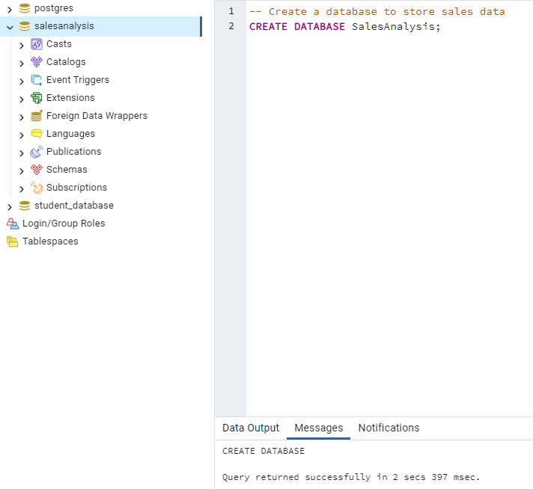

1. Create a table named “sales_sample” with specified columns:

Product_Id (Integer)

Region (varcgar (50) – like East, West etc

Date (Date)

Sales_Amount (int/numeric)

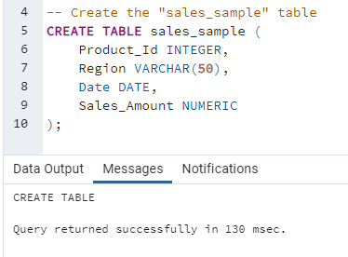

**Step 2: Data Creation**

Insert 10 sample records into the “sales_sample” table, representing sales data.

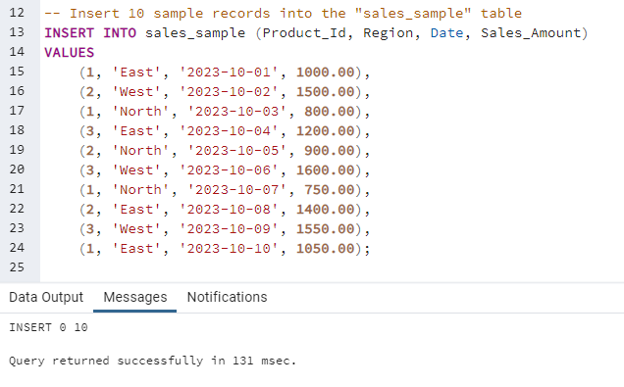

**Step 3: Perform OLAP Operations:**

1. **Drill Down - Analyze Sales Data at a More Detailed Level (Region to Product):**

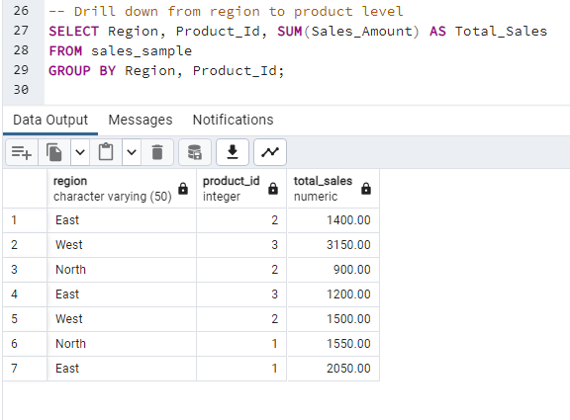

1. **Rollup - Summarize Sales Data at Different Levels of Granularity (Product to Region):**

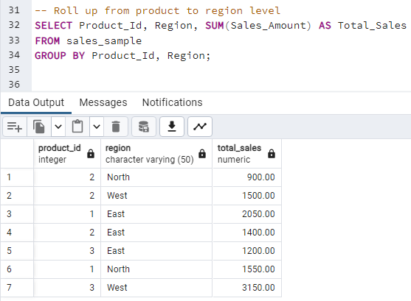

1. **Cube - Analyze Sales Data from Multiple Dimensions (Product, Region, Date):**

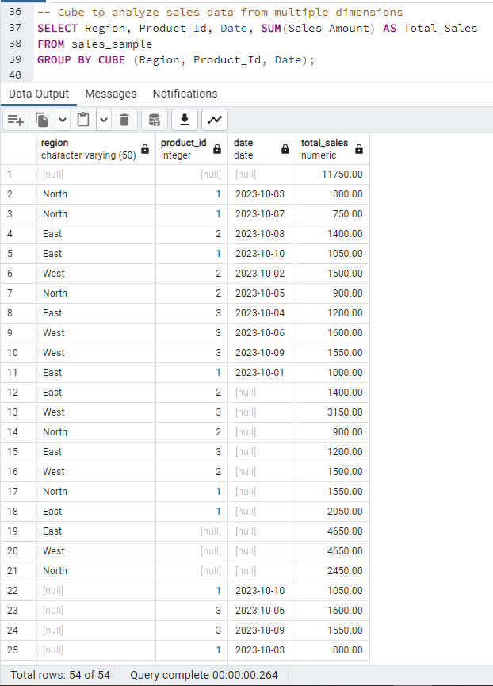

1. **Slice - Extract a Subset of Data Based on Specific Criteria (e.g., Region 'East' and Product_Id 1 on Date '2023-10-01'):**

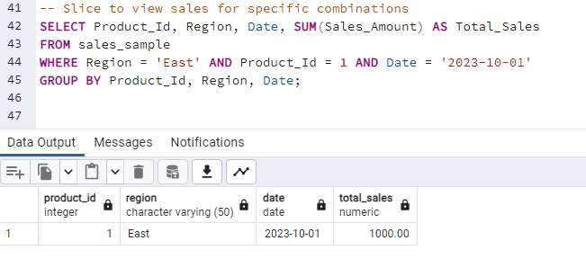

1. **Dice – To extract data based on multiple criteria.**

